**User’s Guide for TerritorialControl QGIS Plugin**

This document introduces the QGIS plugin “TerritorialControl”, which calculates the location and extent of territory controlled by warring parties during civil wars. It relies on data measuring the occurrence and location of violent events to identify the degree to which a warring party exercises control. The territory is calculated as a drive-time buffer from the conflict location to estimate the region where the warring party can project military power within a specified time window. The size and shape of the territory is determined by both on-road and off-road movements on a hybrid transportation network with both existing road/railway data and hexagon-fishnet-based artificial road data. This design guarantees its applicability to countries or regions with inferior transportation infrastructure where off-road movement of the military is common. The results can be used to reflect a quasi-real-time status of territorial controls of a specific region on the map. They can also serve as the input of further scientific analysis.

The Liberians United for Reconciliation and Democracy (LURD)

**Installation**

* **Install QGIS**

The tool is a plugin for the QGIS open source geographical information system program. Details and guides for installing and using QGIS can be found at: [http://www.gqis.org/](http://www.gqis.org/en/site). The instructions below are based on QGIS version 2.18.14 on a computer using the Windows 10 operating system.

* **Install TerritorialControl plugin**

Open QGIS and start a new Project, on the menu find “Plugins” -> “Manage and Install Plugins...”

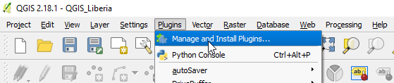

Search the plugin “TerritorialControl” and install it by checking the box in front of it,

After installation (it usually takes a few seconds), the icon will appear on the QGIS menu. The meaning behind the icon  is twofold: first, the hexagonal shape corresponds to the hexagonal grid cells used for modeling territorial control; second, the Yinyang pattern expresses our sincere wish through this old Chinese philosophy: although conflicts and violence always exist, harmony and peace can be achieved.

Clicking the icon you will see the user interface (UI) of this plugin:

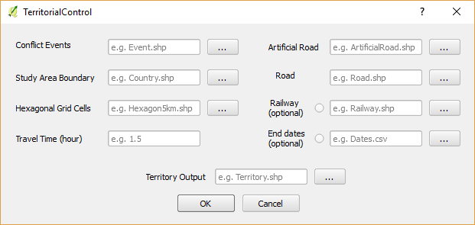

**Configuration**

In addition to QGIS, the plugin relies on external functions from GRASS GIS and SAGA GIS, both of which are included when QGIS is installed. Before installing the plugin, you may need to enable QGIS to access these functions first. Open QGIS, click “Processing” -> “Toolbox” on the menu:

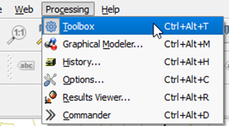

* **Check if external GIS functions exist**

Look at the list of available functions in the Processing Toolbox on the right. If you do not see GRASS GIS 7 commands or SAGA (2.1.X) listed there, you will need to enable them first.

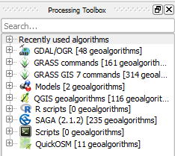

To enable these functions, first click **Processing** -> **Options**, then expand **Providers**, and **activate GRASS GIS 7 commands** and **SAGA**:

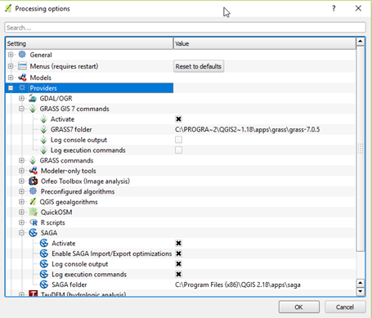

If it returns error such as ‘Wrong value for parameter “Msys folder”’, create an empty folder named “msys”in the “apps” directory where your computer installed QGIS. On most Windows computers, this directory will be something like: “C:\Program Files\QGIS 2.18\apps”. Once you have created the msys folder, repeat the steps above.

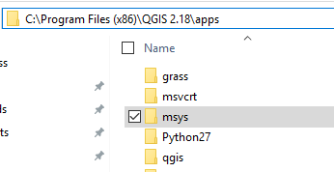

**Preparing Your Data**



Referring to the UI, the plugin takes eight input data or parameter and produces one output: a shapefile identifying territorial control. Users need to prepare these input data and place these in all in the same folder on your computer. The sample data included with the plugin in identifies events in the civil war in Liberia and is named “LiberiaLURD.csv”.

Here is the checklist of all the inputs data and their preparation instructions:

* **Conflict Events**: This is a shapefile (.shp). Users should begin by preparing a file in tabular format (such as .csv). Each row is a conflict event. The file should include columns for the following variables:
  + Date: The date of the event should be in the format “YYYYMMDD”. Name this column “Date_int”. Sort the data chronologically so that the first row of data is the first event.
  + Event Number: This is a unique identifier for each event. The first event should have 1 as its identifier. Name this column “TimeID”. Number the earliest event as 1, and then number subsequent events in chronological order.
  + Warring party: This is the name of the warring party that has established control at the location. Name this column “side_a”.
  + Control: This the the level of control exercised by the warring party at this location. Name this column “Ctrlcode”. The values should be integers ranging from zero to 8.
  + Latitude: the latitude of the event.
  + Longitude: The longitude of the event.

Save the file as **CSV** (comma delimited) (*.csv) file.

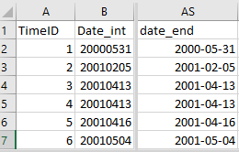

The next step converts this .csv file to shapefile format. In QGIS, use one of the following ways to “Add Delimited Text Layer”:

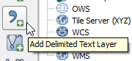

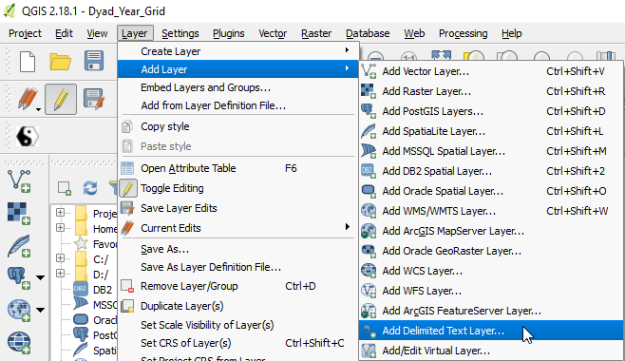

Load the CSV file. Set the “x field” and “y field” as longitude and latitude, respectively. Click “OK” to add the event point layer.

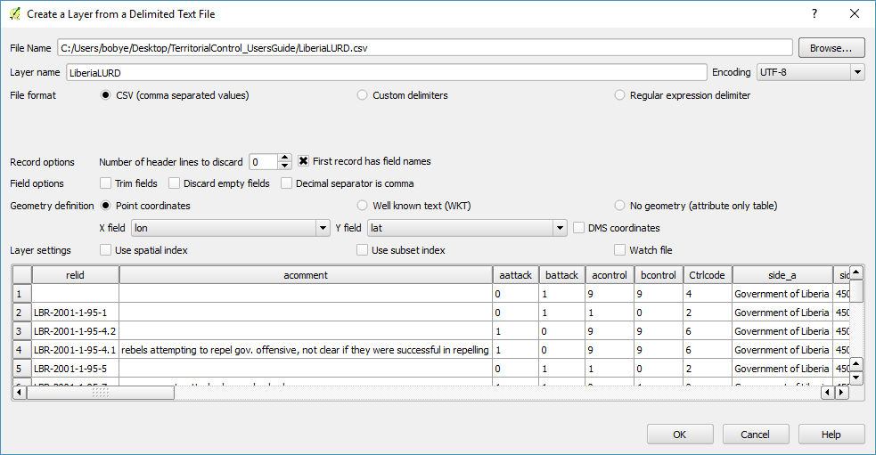

The map projection of the event point layer is recommended to be consistent with all other spatial layers. For example, all the spatial data layers in the sample data are using the same map projection system, namely “Africa Equidistant Conic”. Therefore, (re)project your event point layer if needed. The projection can be found in Processing => Toolbox, and search “Project”.

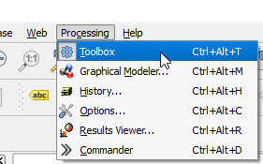 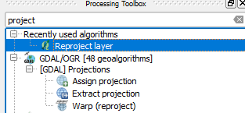

As part of the plugin, we provide sample data for the conflict between the Government of Liberia and the LURD rebel group. The .csv file with the variables described above is named “LiberiaLURD.csv”. It contains information on 53 violent events involving these two warring parties. These conflict events are drawn from the Georeferenced Event Dataset (GED) [2]. The GED provides information on the identity of the warring parties, the location and time of each event, and other variables. It also includes the original sources (such as media reports) used to generate this list of events. We located these sources and coded the attack and control variables described above, and used these to calculate the level of control for each event.

* **Study Area Boundary**: a shapefile defining the boundaries of the study area, for example, a country experiencing civil war. In the sample data, the boundary of Liberia is provided with filename “Liberia.shp”.
* **Hexagonal Grid Cells**: a shapefile of hexagonal cells covering the study area. These cells can be of any size. Note, though, that smaller cells increase the processing time needed to generate the territorial control data.In the sample data we provide hexagonal cells in two spatial resolutions: 3km and 5km in terms of the edge length.

The hexagonal grid cells can be easily created in QGIS geoalgorithms => Vector creation tools => Create grid:

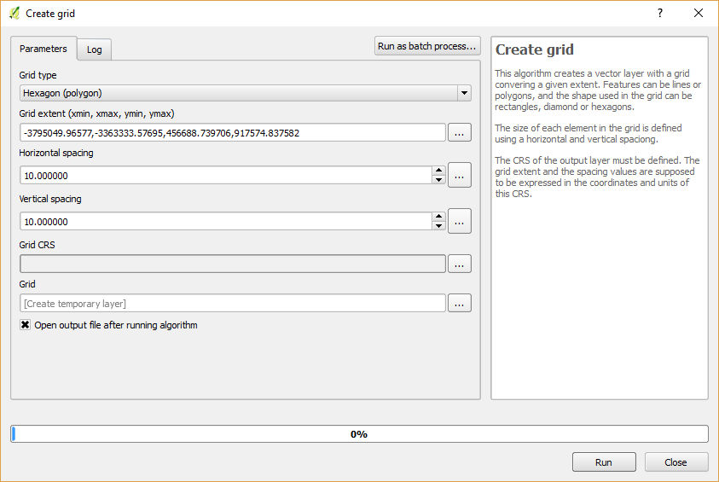

* **Travel Time**: The parameter partially decides the size of the territory. We calculate territory as a drive-time buffer from the conflict location as to simulate the region where the warring party can project military response in a timely fashion. So this parameter decides the temporal frame of the military response. A reasonable parameter value often falls in the range from 0.5 hour to 2 hours. Users can choose the value to best fit the context of their study.
* **Artificial Road**: A shapefile of artificial road network with corresponding travel speed. This is an essential part of the analysis. The artificial road is to model off-road movement, which is a commonplace in countries or regions with inferior transportation infrastructure. The artificial road shapefile data is created based on hexagonal grid. The travel speed varies from place to place by considering land cover, slope, and river system. The detailed approach for preparing the artificial road network is elaborated in [1]. In the sample data, the artificial road file is “Liberia_ArtificialRoad-5km.shp”.
* **Road**: A shapefile of the road network with corresponding travel speed. In the sample data, the road file is “Liberia_Road.shp”.
* **Railway (Optional)**: A shapefile of the railway network with corresponding travel speed. Note that this data is optional given some country or region may not have railway. Check the checkbox to enable it. In the sample data, the railway network file is “Liberia_Railway.shp”.
* **End dates (Optional)**: This option enables calculating a batch of results simultaneously. If the checkbox is unchecked, the plugin only calculates one result representing the final status after all the events. But if you want some intermediate results, for example the status by the end of each year, you can check the box and input a CSV file that lists in a single column the end-dates for each period you wish to create. For example, to have the result last day of the year in 1989, 1990, and 1991. Your .csv file would look like this:

|  |
| --- |
| 19891231 |
| 19901231 |
| 19911231 |

By enabling this option, the algorithm only takes the events between the earliest event until the designated end time, and calculates the territories for this time window. Note that the dates in this file must be in the format “YYYYMMDD” as it is to compare with the variable “Date_int” you created earlier. You could also create end dates for shorter periods than a year. For example, if you want the end-dates for your study to be the last day of the first three months of 2017, the .csv file would look like this:

|  |
| --- |
| 20170131 |
| 20170228 |
| 20170331 |

**Produce Output**

Click on the icon icon.PNGto run the plugin.

We provide a set of sample data looks shown in the map below. The country of Liberia is the study area. The conflict events are the 53 UCDP-GED records between the Liberian government and LURD from 2000 to 2003. Three prepared transportation network data, namely road, railway, and artificial road with calculated travel speed.

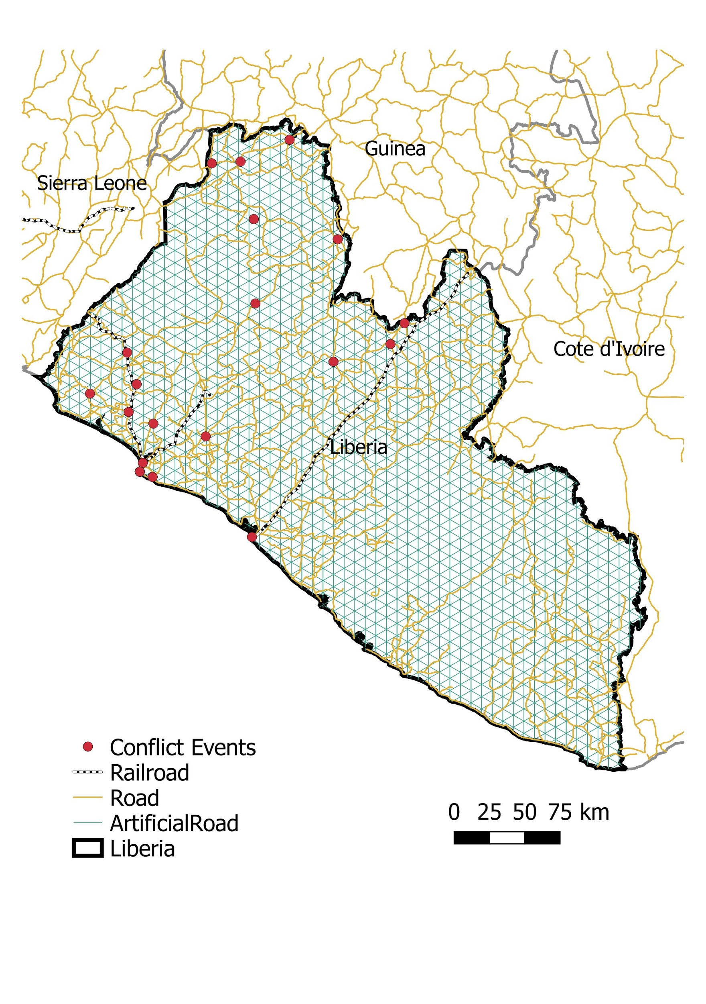

To generate the territories using one-hour travel time and 5-km spatial resolution, set the UI as below. The **Territory Output** file name includes the information of the two warring parties, the travel time, and the spatial resolution: “Liberia_LURD_1hr_5km.shp”. Note that the **End dates (Optional)** is blank, which means this will only generate one result representing the territorial control status by the end of the last event (2013-11-21). Click “OK” to run it. The calculation is not so fast, for this sample test it takes about 10 minutes.

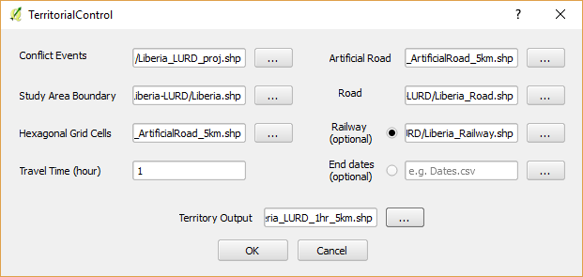

The plugin automatically generates an intermediate result, which is the “Reachable Road Network”. It reflects how far the warring party can project its military force along the hybrid transportation network within the given travel time from a certain conflict location.

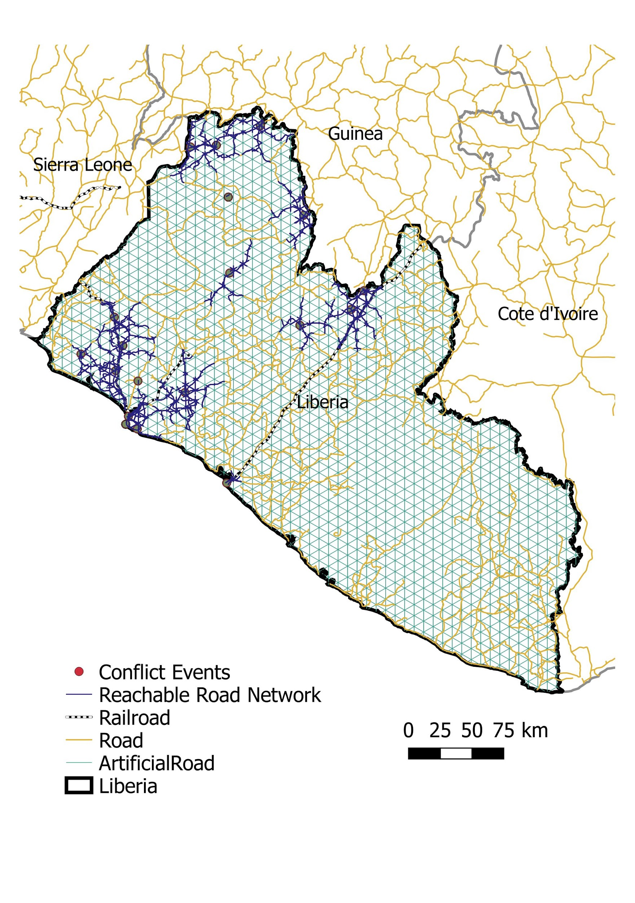

The **Territory Output** is saved in the assigned directory. Load it to QGIS and it looks like:

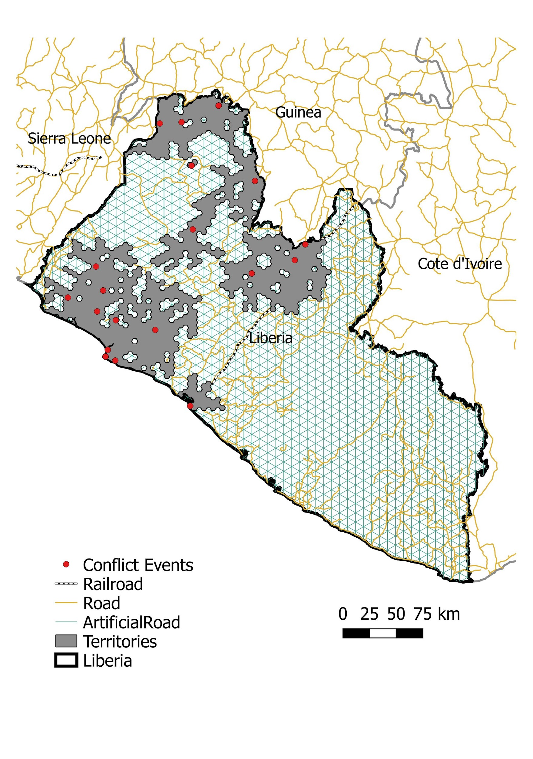

To generate a batch of results, you can enable the option of **End dates** and input a CSV file including the dates you want for each result. For example, the setting below will generates the results by the end of each year during the warring period between the Liberian government and LURD:

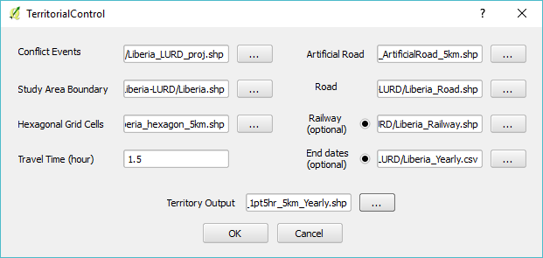

The CSV file “Liberia_LURD_Yearly.csv” looks like:

|  |
| --- |
| 20001231 |
| 20011231 |
| 20021231 |
| 20031231 |

The territorial results will be saved as shapefile in the names of: “Liberia_LURD_1pt5hr_5km_Yearly_20001231.shp”

“Liberia_LURD_1pt5hr_5km_Yearly_20011231.shp”

“Liberia_LURD_1pt5hr_5km_Yearly_20021231.shp”

“Liberia_LURD_1pt5hr_5km_Yearly_20031231.shp”

**References**

[1] Ran Tao, Daniel Strandow, Michael Findley, Jean-Claude Thill, James Walsh. (2016). A Hybrid Approach to Modeling Territorial Control in Violent Armed Conflicts. *Transactions in GIS* 20(3): 413–425.

[2] Sundberg, Ralph, and Erik Melander. (2013). Introducing the UCDP georeferenced event dataset. *Journal of Peace Research* 50(4): 523-532.